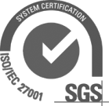

RE SUPPLIER SPACE
Supplier User Guide

Support Department

Contents

- INTRODUCTION 4
- HOW TO REGISTER IN THE SUPPLIER SPACE > 4
  - REGISTER 4
  - ACCEPT CONDITIONS 5
  - GENERAL COMPANY DETAILS 6
  - COMPANY BUSINESS 8
  - USER DETAILS 10
  - REGISTRATION CONFIRMED 11
- HOW TO ACCESS THE SUPPLIER SPACE> 13
- FILLING IN THE GENERAL INFORMATION QUESTIONNAIRE > 15
- CLASSIFICATION FILE 18
  - INTRODUCTION 18
  - REGISTERING THE CLASSIFICATION FILE 19
    - Manufacturing and Supply Data (Type 2 Business Area Approval of equipment) 21
    - Request Qualification File Registration 23
    - Validation of the Request File 25
    - Informative message 27
  - QUESTIONNAIRE ASSOCIATED WITH THE BUSINESS AREA 27
    - Filling in the questionnaire and sending it 28
  - AS SUPPLIER I CANCEL A CLASSIFICATION PROCESS 31
  - AS SUPPLIER I REQUEST DELETION OF A CLASSIFICATION PROCESS 32
  - RE MANAGER RETURNS FILE TO SUPPLIER 34
  - AS SUPPLIER I RETURN FILE TO RE MANAGER 35
  - AS SUPPLIER I DO NOT RETURN THE FILE TO THE RE MANAGER IN THE SET PERIOD (DEADLINE FOR RETURN) 38
  - RE Manager > APPROVE CLASSIFICATION FILE 40
  - RE MANAGER REJECTS CLASSIFICATION FILE 41
- OTHER QUESTIONNAIRES: REPRO AND AXESOR 43
  - REPRO QUESTIONNAIRE 43
  - AXESOR QUESTIONNAIRE 43
- SUPPLIER FILE 44
- CLASSIFICATION REPORT 46
- CIF MODIFICATION REPORT 48
  - INTRODUCTION 48
  - REGISTRATION CIF MODIFICATION REQUEST 49
    - Documents required for the process 50
    - Reason for Modifying CIF 52
    - Request CIF Modification Registration 53
  - TRACKING CIF MODIFICATION REQUEST 55
    - RE Manager returns the request 55
    - As Supplier I return the request to the RE Manager 57
    - RE Manager approves the request 58
    - RE Manager cancels the request 59

Introduction

This document describes the main functions that suppliers can use in the supplier space.
From how to register and report the basic details of the company, accessing the private area in the supplier space when authorised to do so and how to start qualification processes.

How to register in the supplier space >

Registering

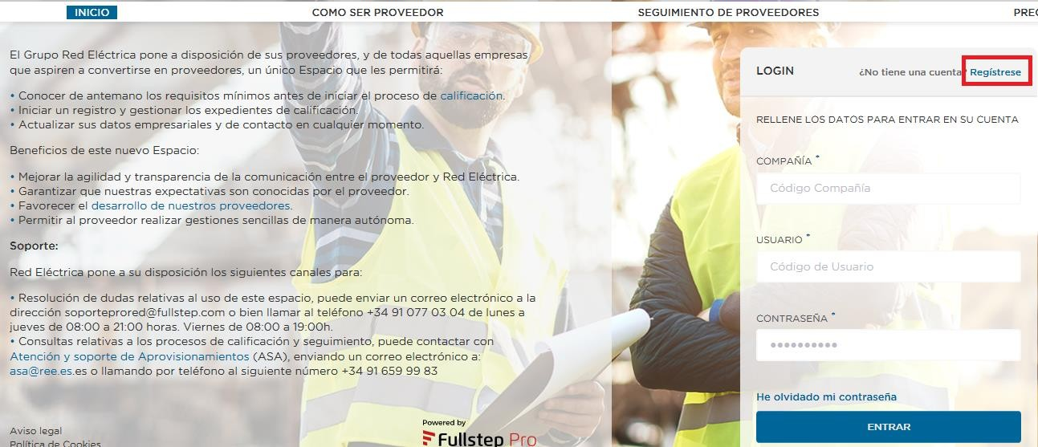To be a supplier, you must first of all request registration. To request registration, click on the “Register” link on the home page.

This document will explain the steps to follow to request company registration online.

To submit a registration request please follow these steps:
    - Accept the conditions of use
    - Fill in the form with the company details:
      - Complete the general company details
      - Complete the companies business activities

      - Complete the User details
      - Confirm the registration

There are help icons throughout the registration request form that will activate as soon as you click on them.
Fields marked with an (*) must be completed.

Accepting the conditions

Before continuing and adding details, you must indicate that you have read and accepted the different documents published in this section.
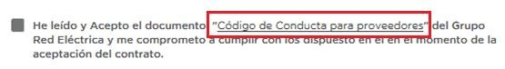Each point for acceptance contains a link to consult the relevant document, which must be read and accepted.

If you want to continue the registration process, you must select the verification boxes “I have read and accept...”, then click on the “Continue” button

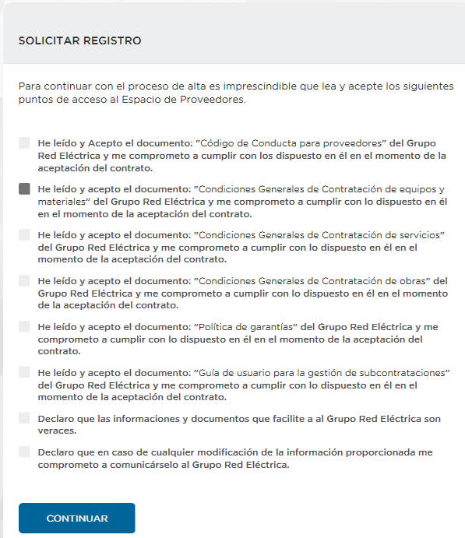General company details
The first stage asks for general details about the company:

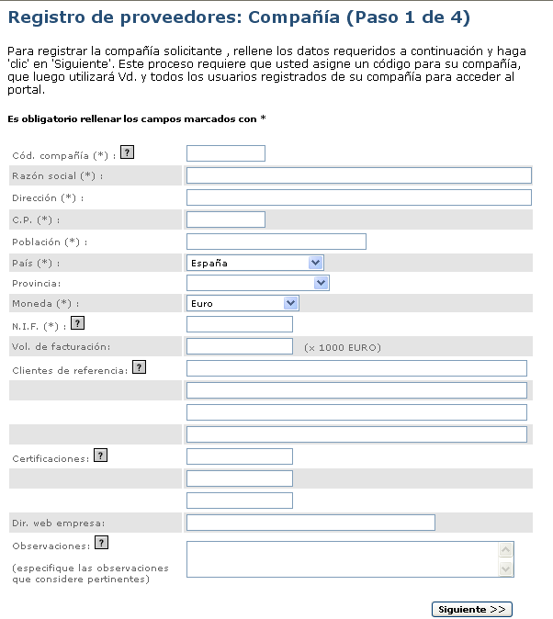Click to continue the registration

- Company Code: Code that identifies the company. This is the first of the three passwords needed to access the private supplier area once registration has been requested. It can consist of numbers and letters. Do not use special characters or leave blank spaces.
Despite being a field which you are free to fill in, we recommend that you click on the icon to get help on how to fill in this field
- Business Name: The official name of the company.
- Address: The address of the company.
- Postcode
- Location: Location of the company
- Country
- Province
- Currency: Currency in which the financial data is expressed.
- Tax ID: Number for Tax Office Identification. (Written without spaces or hyphens between letters and numbers)

- Turnover: Annual revenue of the company in thousands of euros.
- Principal customers: If the purchasing company is your customer please mention this, as well as any other customers you consider relevant.
- Certificates: Specify whether the company possesses a quality certificate or an ISO standard of if these are under way.
- Web site: Indicate the company’s web site.
- Observations: Space to include comments that the supplier considers to be relevant for the purchasing company.
To continue the registration process, click on next.

Company business

The next step in registration is to indicate the business areas of the company. This means that the RE Group can see which products and services each supplier is able to provide.
Please select at least one business area.

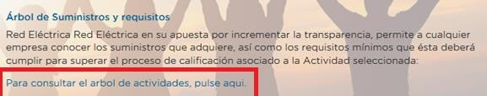To make it easier to select activities, we recommend checking the activity tree in the “How to become a Supplier” section, which you can download in Excel format by clicking on the link.

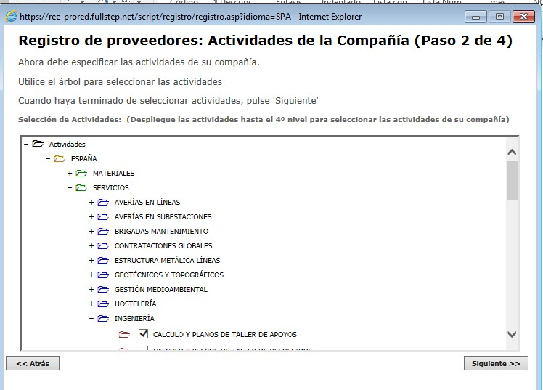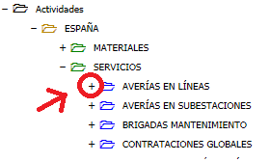To select the activities, please use the drop down menu and click on the plus signs (+) for each branch, which will open the folders they contain,

Repeat this action until you reach level 4, where you can select the activity by clicking on the appropriate verification box.

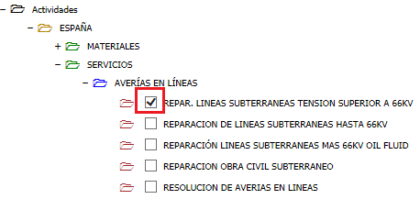To continue the registration process, click on next.

User details
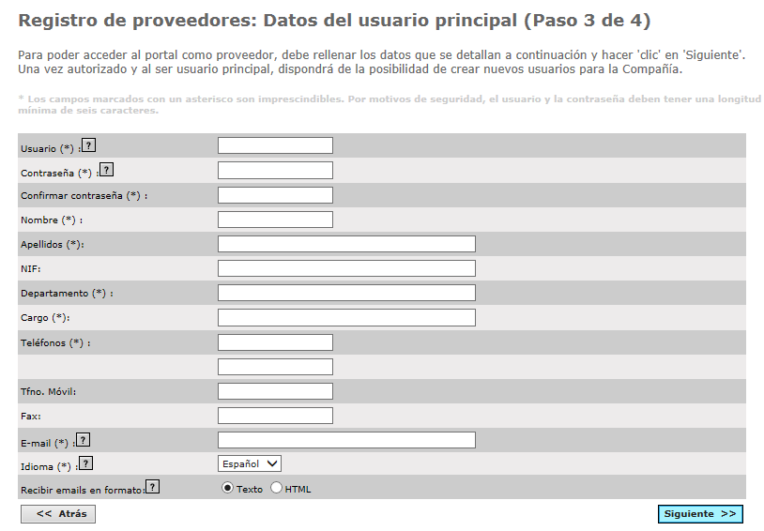This section will ask for details about the company’s contact person:

- User code: Personal user code (minimum six characters). This is the second of the three passwords needed to access the private supplier area once registration has been accepted. This code need not match the company code registered in “General Company Details“.

- Password: User password of at least six characters. This is the third of the three passwords needed to access the private supplier area once registration has been requested.
Neither the user code nor the password can include special characters or blank spaces.
- Personal user details: Surname, name.
- ID of the person mentioned in the previous fields. This is optional.
- Department Area of the company the user belongs to.
- Position: Indicate the user’s post within the company
- Telephones: Provide at least one contact telephone number.
- Mobile phone: Provide the user’s mobile phone number.
- Fax: Provide the fax number.
- E-mail: Provide the e-mail address for the user who will be working in the private area.
This e-mail address will be used to inform of the existence of significant new transactions and information, so it is vitally important to ensure that this address is updated.
- Language: Indicate the language you wish to work with.
- Receive e-mails in format: Please indicate the type of format you prefer to receive the e-mails from the purchasing company (text or html)
To continue the registration process, click on next.

Confirm the registration
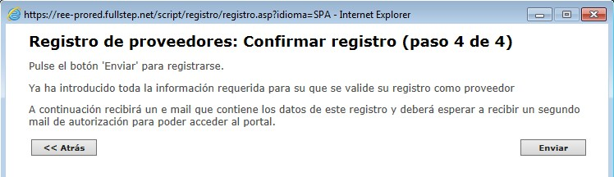Once the required information to request registration has been entered, you will see a screen similar to the following.

If you want to check the data entered, click on the Back button which appears in every step of the registration process.
Once you confirm that the data is correct, click on Send to begin processing the registration request.

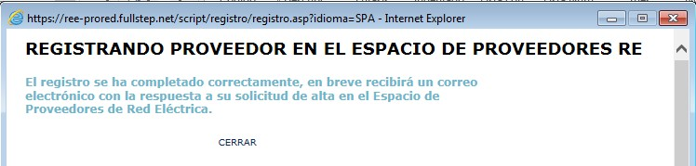You will finally receive notification by e-mail to confirm your registration in the portal, sent to the address you have given in your main user details.

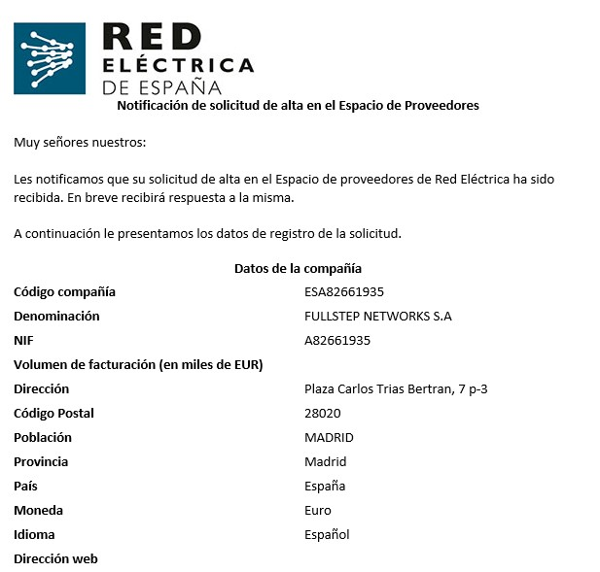An example of the body of the e-mail to notify registration in the portal is shown below.

IMPORTANT
When the registration process is complete, you must wait for a second e-mail to confirm your access to the supplier space.

The system will not grant you access unless you have received confirmation by e-mail.

How to access the supplier space>

To access the private area of the RE Supplier space you must complete the whole registration process and be authorized to do so.
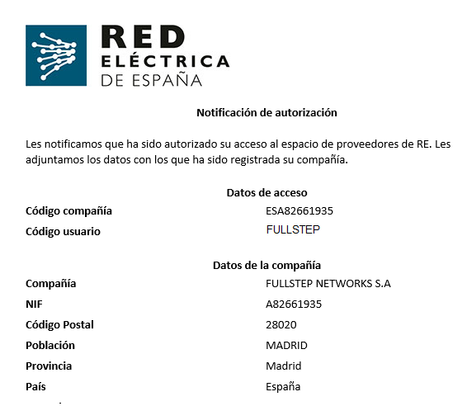You must have received an e-mail similar to the one shown below.

The mail will have a reminder of the company and user codes, but the password is not given in any e-mail for security reasons.

To access the private area of the RE Supplier space, enter your access credentials and click on “Enter”

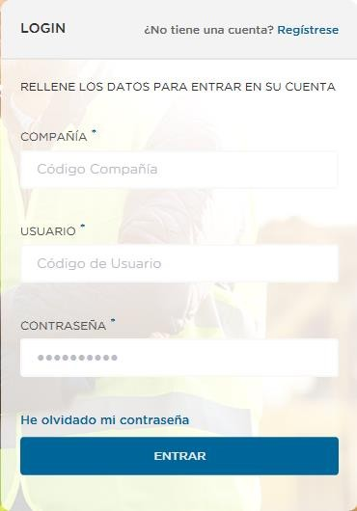If you cannot remember the password you used when registering for the supplier space, you can change it by using the “I have forgotten my password” link
The system will request your company and user codes and the e-mail address associated with the user.
You will then receive a mail to reset your password.

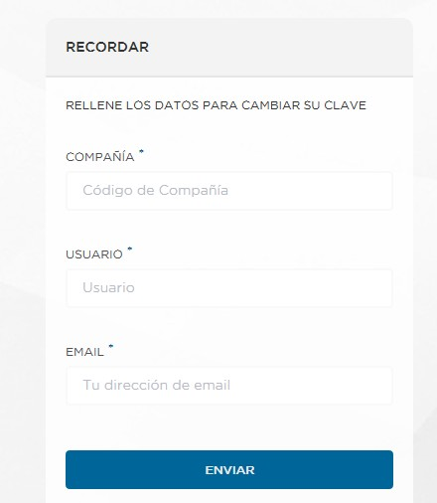Filling in the General Information questionnaire >

A few minutes after receiving the notification that authorizes you to enter the supplier space, you will receive another message requesting that you fill in a general information questionnaire.
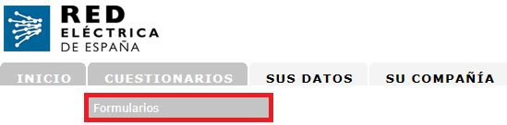To access its content, you must first access the private area of the supplier space using your credentials, then go to the menu option Questionnaires > Forms.

It is essential that you send this form before you request the registration of a qualification file.

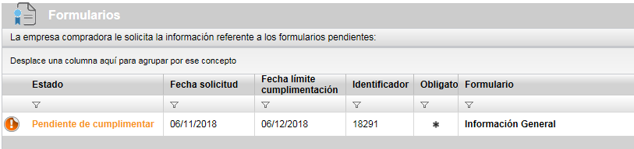To see the details of the questionnaire, click on the title “General Information”

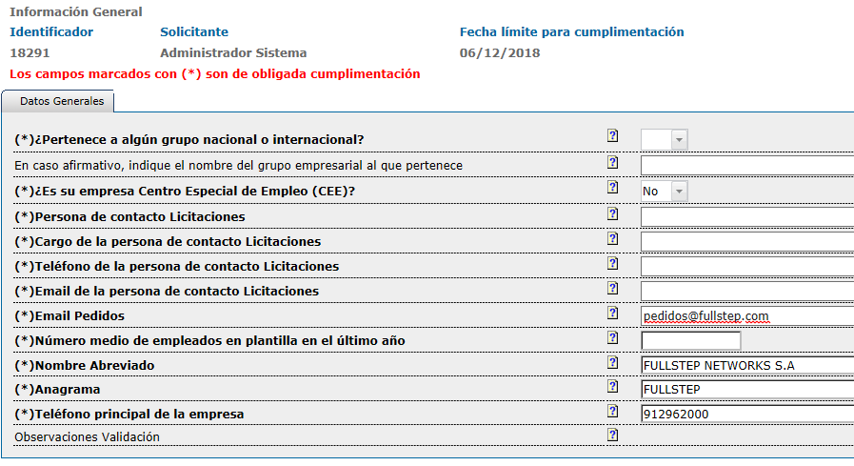The questionnaire may already have fields completed with the details of your company available to the RE Group, but you should check them and update them where appropriate.

You will find a series of mandatory fields (marked with an asterisk) that you have to fill in.
If you try to send the questionnaire without these mandatory fields, the system will return the following message:

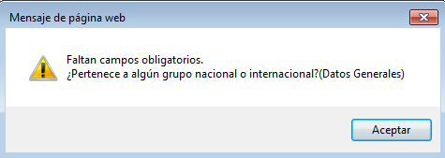

The system has support sections (the question-mark buttons) which will explain what is required in each case.
Clicking on the help icon will open a window explaining:

Once the minimum mandatory data has been filled in, click on the “Send Details” button to send it.

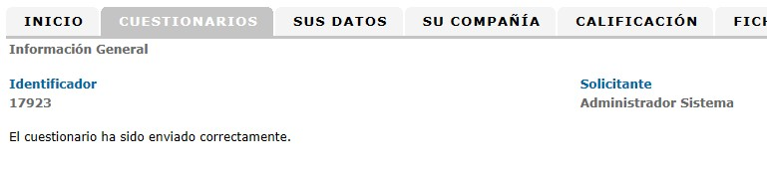The system will display the following confirmation message.

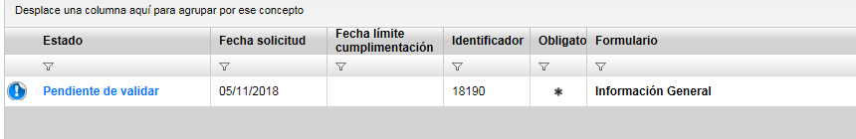To see the list of questionnaires, open the menu option “Questionnaires > Forms” again. Once sent, the status of the form is Pending Validation.

When the RE manager checks and validates the details, the status will change to Valid. The status of the general information form must be Valid for the system to allow you to request registration for a qualification process.
If an error is detected in the information, the status will be Invalid, and the Validation Comments field will explain the reason why the questionnaire is considered to be invalid.

IMPORTANT
Once the General information questionnaire is Valid, it is not advisable to send your details again unless there is something that has to be updated.

Qualification File

Introduction

The qualification file contains the qualification process that the supplier starts in relation with the business area.
The supplier starts the qualification process by indicating its business area (supply, materials or services).

The business area is the combination of supply and scope (Spain or Latin America) and can be one of the following types:

Type 1 and type 6 business areas: In both cases, the standard qualification process must be passed, which means a series of minimum technical and sustainability standards associated with the activity.

- Type 2: Besides passing the standard qualification, the supplier must also satisfy requirements to have its equipment or material approved.

- Type 3: The supplier must pass a standard qualification process and a personnel skills process (certain jobs can only be performed by the supplier’s employees who have passed a qualification examination set by Red Eléctrica).

- Type 4: The supplier must pass a registration process in which it must provide sales and business information about the Business area in question. A standard qualification process is not required.

There are no type 5 activities.

A questionnaire in the suppler space must be completed for each business area for which a qualification process is started.

The different activity types, and the minimum requirements for the associated questionnaire, can be seen in the “How to Become a Supplier” section

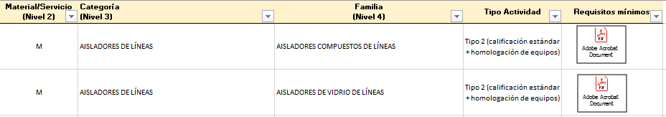The activity tree and their types can be opened in Excel format to consult the minimum requirements before starting a qualification process.

Registering the qualification file

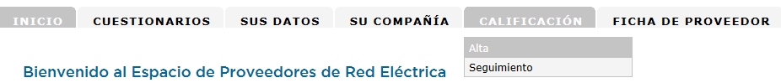As an authorized supplier, you can request the start of a qualification process by using the Qualification > Register menu option

The system will then display the “Qualification File” type

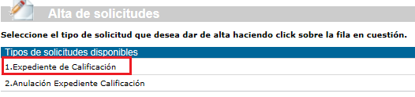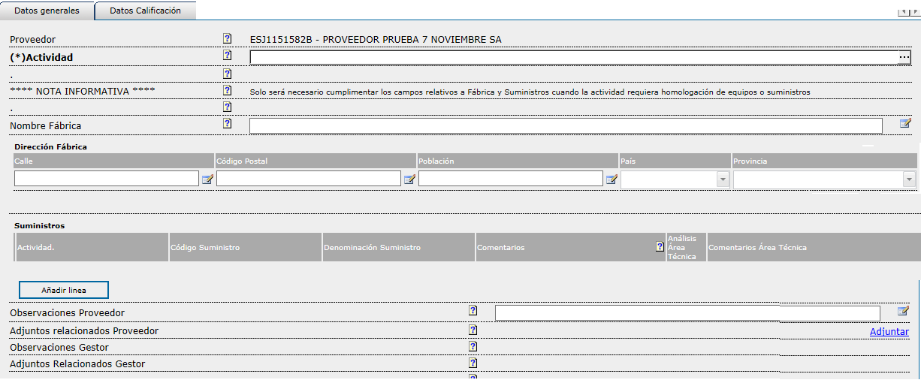Click on the title and the system will display the form for the file with the data to be completed by the supplier.

Qualification file form

The business area is a detail that must be completed. Click on the red button to select the activity that qualification is requested for

One activity must be selected (4th level of the activity tree).
This window does not allow searches by activity name.

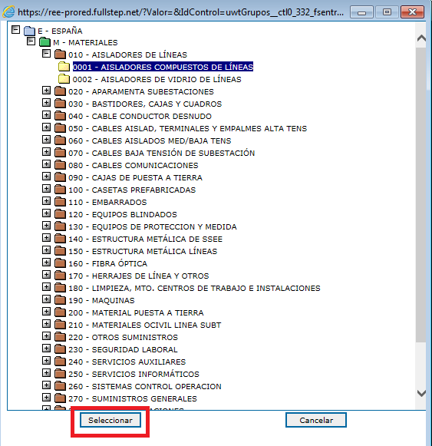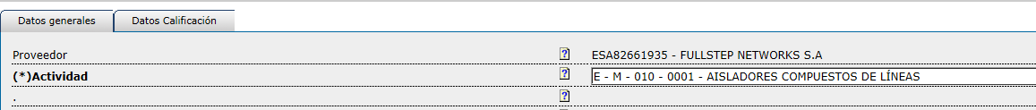You can select any activity on the tree for which you want to be qualified, regardless of the business areas you may have selected in the portal registration request.

Manufacturing and Supply Data (Type 2 Business Area Approval of equipment) 21

If you request registration of a process for a type 2 activity, the system will require that you complete the details of the Factory (name and address) and select at least one item to supply.
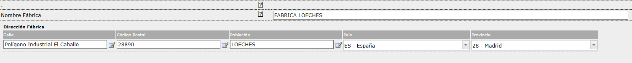If the selected activity is not type 2, the system will not allow you to enter information in these fields.

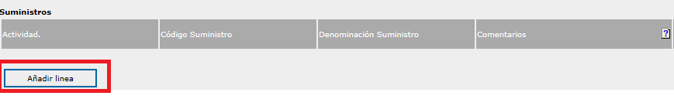To select the supplies, click on the “Add Line” button

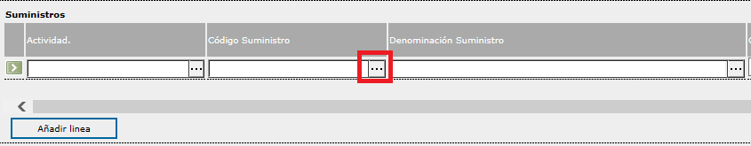Then click on the button highlighted in the red square

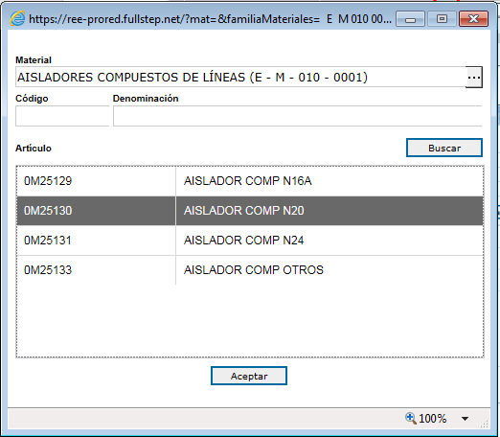To enter the supply selection window.

Select a supply and then click on “Accept”
The selected item will then appear in the line. There is an option to add comments

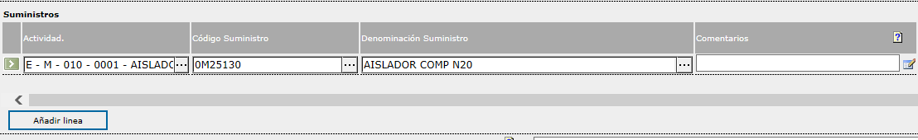The system allows you to add various supply lines.
The codes of the selected items cannot be repeated.

Request Qualification File Registration

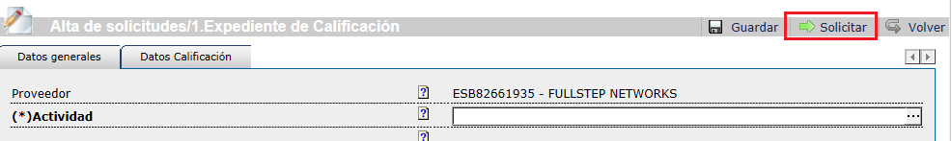

Save ->
The system will generate a unique numerical identifier for the file.
The file will be in “Saved” status.
The supplier can access the details of the saved file from the menu option
“monitoring” -> “saved files” and has the option to:
Delete the file
Open the file (and modify details if necessary) and click on “Request”.

Request ->
The system will make the validations indicated in the next point. Once the validations have been made, the system displays an information message:

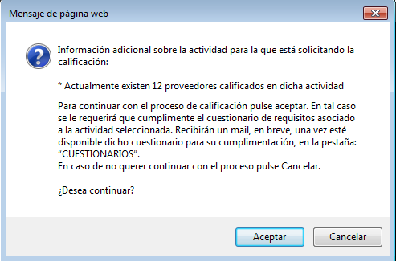

Click on the “Accept” button and the system will then show the following confirmation page.
There is no need to add any comment for the following participants.

The “Accept” button must be clicked again to confirm the registration of the file.
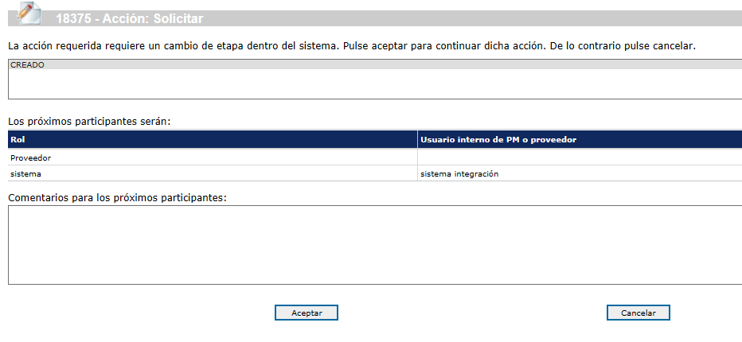The file number is indicated at the top of the page. This number is exclusive for this file.

File registration request by the supplier Click on ACCEPT to Continue

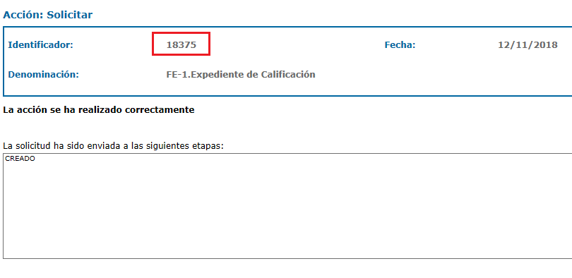Confirmation page. File created correctly

Validation of the File Request

The system will run the following tests after the “Request” button is clicked:

- The supplier must have completed the
“General information” questionnaire and it must be valid

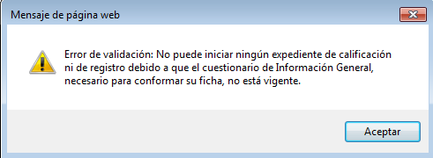

Please check that the General Information questionnaire is duly completed and in “Valid” status (menu option Questionnaires - Forms). If the status is Pending Validation, you must wait for the Supplier Department to validate the file.

- The number of files “in progress” or “created” for the business area and supplier in question are checked and if 1 is found, the system will display a block message.

This validation applies to any type of activity, except for type 2 (qualification activity with approval).
Block message:
“A new qualification process for the selected activity cannot be started because there is already a process in progress or created for the same case”

- The system will check that the supplier is in REPRO (there is a REPRO form for the supplier) and the Supplier Status field in RePro is valid.
This validation applies to any type of activity, except for type 4.
Block message:
“Starting a new qualification process in this business area requires your company to be previously registered in REPRO with a Valid status”

Status Status
Entered First year-Not paid KO
Entered First year-Sent OK
Entered First year-Received OK
Registered OK
Registered-Update Sent OK
Registered-Update Received OK
Re-registered-Sent OK
Re-registered-Received OK
Deleted-Not paid First Year KO
Deleted-Not registered First Year KO
Deleted-Not renewed KO

- The system calculates the number of different type 1, 2 and 3 activities that the supplier has in “in progress” and “created” files. If the number of activities is greater than 3 (value that can be set in the system to apply to all suppliers), the system shows the following block message:

Block message:
“A new qualification process cannot be started because there are currently files in progress for N different activities”.

- The system checks that the type 1, 3 and 4 activities that the supplier has for the selected activity are not in one of the following qualification statuses:
Shows interest Pending First Order

Qualified Warned Blocked
Block message:
“Because your qualification (or registration) is valid for this activity we cannot
start this process again”

For type 2 activities, the supplier can be in PPP, Qualified or Warned and start the qualification process. It is not possible if it has been Blocked.

- If the Supplier already has a Qualification Status for this business area which is “Rejected” (only in type 1 and 3 activities) the system will check the Expiry date for blocking new qualifications. If this date is later than the present it is not accepted. The system will display the following block message that prevents any request for a new qualification process:

“A new qualification process cannot be started for this business area until after
the date: dd/mm/yyyy”

This block does not exist for type 2 and 4 activities. There is no block period for type 4 activities for starting a new qualification process.

Informative message

The system shows the supplier a warning message (emerging window) with the following information:
      - The number of suppliers qualified for the business area.
      - Whether the family requires personnel approval or training (only for type 2 and 3 activities).
      - If the selected activity is type 4, the system will show the following warning message:
“The goal of this process is to complete the registration of your company in the Portal through the completion of a questionnaire of business references that will be provided shortly, associated with the selected activity”.

5.3 Questionnaire associated with the activity

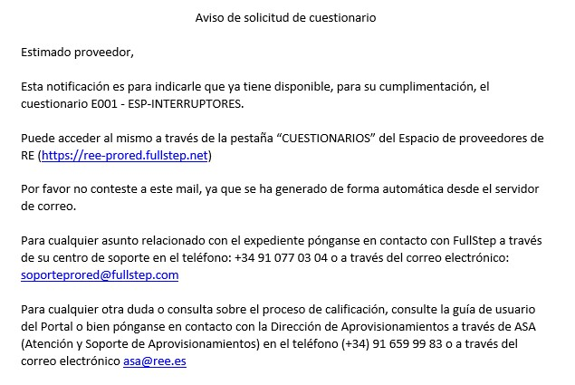Some minutes after requesting the registration of the file you will receive a mail to inform you that before starting the process you must complete a questionnaire associated with the activity.

5.3.1 Filling in the questionnaire and sending it

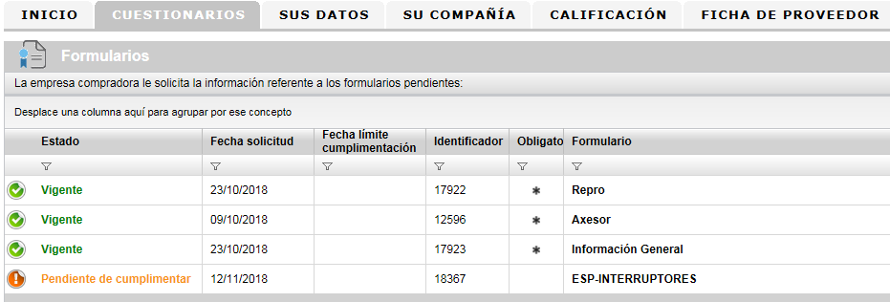To see the details of the questionnaire, click on the menu option “Questionnaires – Forms”. This option contains the questionnaire pending completion.

To access its content, click on the questionnaire title, in the example “ESP -
SWITCHES.

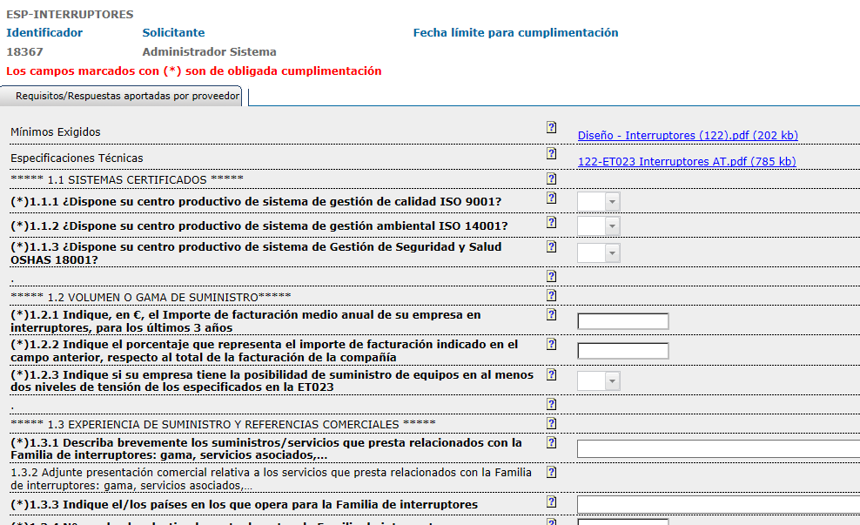We can check the questions and download and see the files with the minimum requirements and the files with the technical specifications.

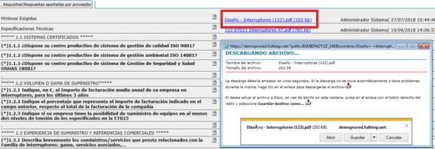To open/download the files with the minimum requirements and technical specifications click on the link with the name of the file and the browser will then ask whether you want to open or download it.

Example of a Minimum Requirement document download with the Internet Explorer browser

If you decide not to continue with the qualification process after reading the minimum requirements and technical specifications, you can cancel the process.

To continue the process, fill in the questionnaire and click on “Send
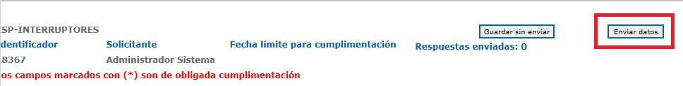Data”.

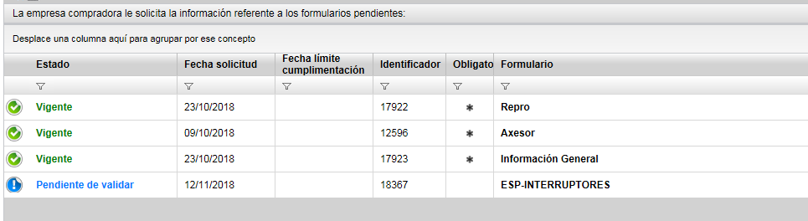The questionnaire will be in Pending Validation mode waiting for RE Supplier Management.

After a few minutes, the file status will change to “IN PROCESS (RE MANAGER)”, you will receive a message as shown below to indicate that the validation process for the file has started.

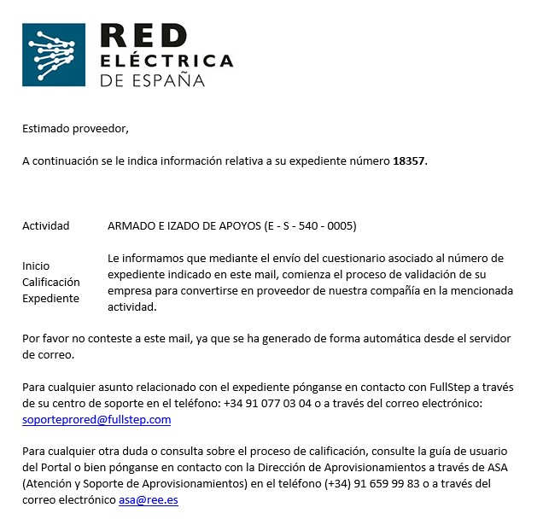As supplier I Cancel a Qualification Process

If your company decides not to start the qualification process and has not filled in the associated questionnaire, the file can be cancelled.
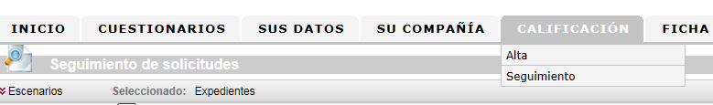To do this, open the menu option: “Qualification – Monitoring”

Locate the qualification file in this option which is in the “Pending Supplier” status, because the associated questionnaire has not yet been submitted.
Click on any of the columns to access the details of the file.

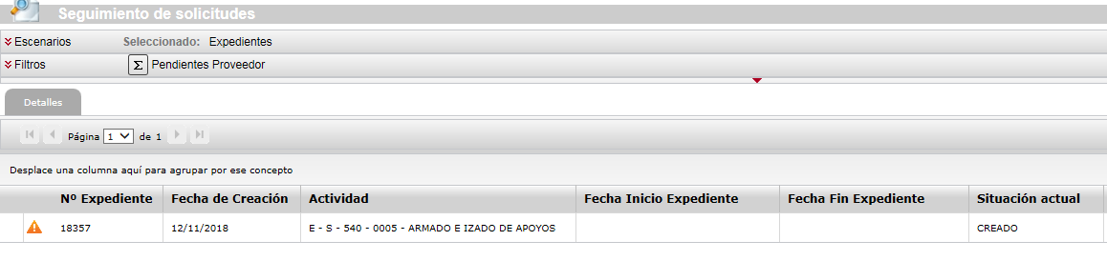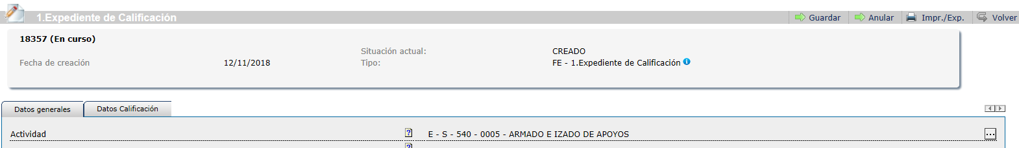To cancel the qualification file click on the “Cancel” button

As supplier I request the deletion of a Qualification Process

If you decide not to continue with the processing of a qualification process as a supplier, you can request its cancellation. The steps to follow are explained below.
First of all, we check that the file is in the IN PROGRESS status and not CREATED (in which case we can handle the deletion ourselves).
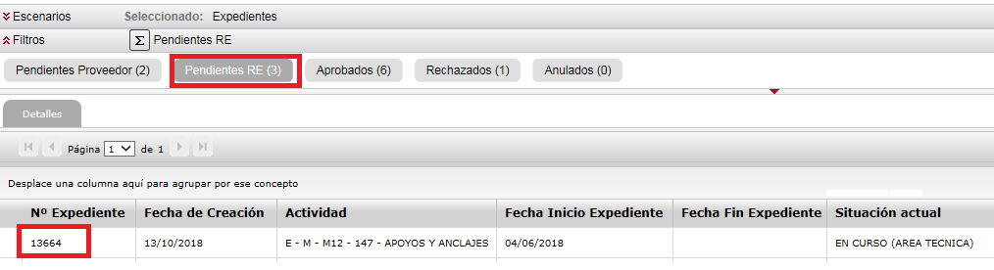1._ Access the menu option “Qualification – Monitoring”, select the “Pending RE” or "Pending Supplier” filter and take note of the number of the file to be deleted.

2._ Enter the menu option “Qualification – Registration”, select the type “Cancel the qualification process”

- 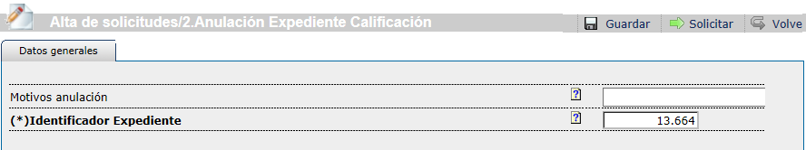._ Fill in the form, indicating the number of the file to delete.

There is the option to indicate the reason for the cancellation.

- 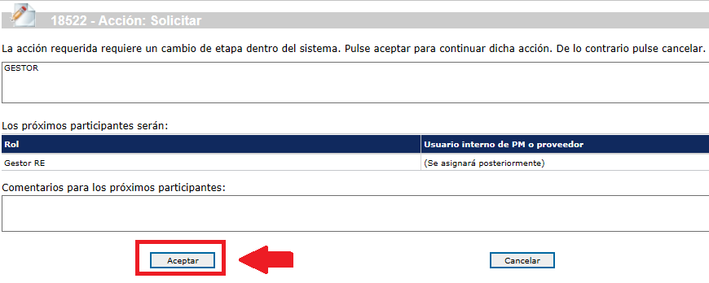._ Click on the “Request” button and then click on “Accept” on the confirmation page

Your request will be handled by an RE Manager.
- ._ When the cancellation of the qualification file has been processed by the system, the result will appear in the supplier space. The system will not send any automatic notification of the process.
When the qualification file is cancelled, it can be checked in the menu option “Files” - “Cancelled” Filter

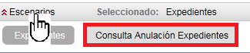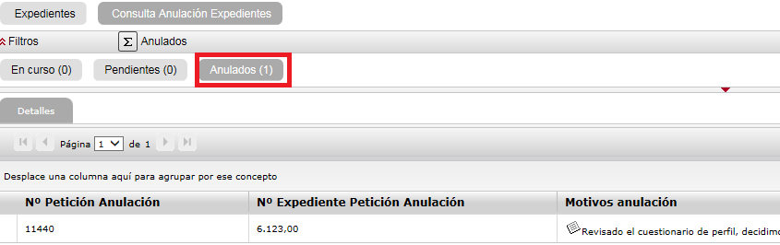When the request for cancellation is finished we can check the result under the “Qualification – Monitoring” menu option. Select the scenario “Consult File Cancellation” using the “cancelled” filter

RE Manager returns the file to the Supplier

Once the questionnaire associated with the business area has been completed and sent, the supplier department of RE will assess it.
The RE Manager may return the questionnaire to the supplier because some further action is needed.
if this happens, you will receive an email message with the subject line:

Return Qualification File / RE Suppliers
The body of the mail will contain the comments by the manager and the date on which the file must be returned to the manager (deadline for return)

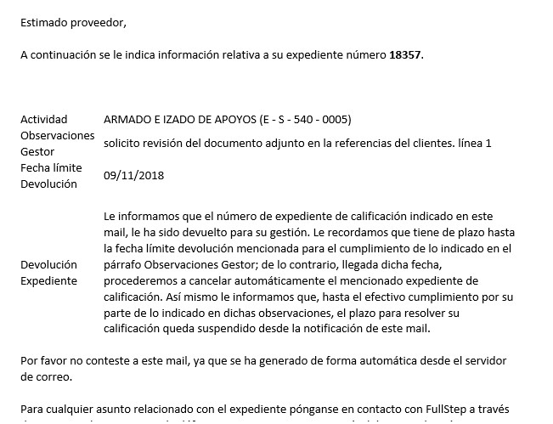IMPORTANT
The RE manager indicates a deadline for the qualification file to be resubmitted. The file will automatically be cancelled on the day after the deadline.

As Supplier I return the File to the RE Manager

To access a file that has been returned by the Supplier Manager, open the menu option: Qualification > Monitoring.
To see the details of the file, click on any of the columns corresponding to the file line:

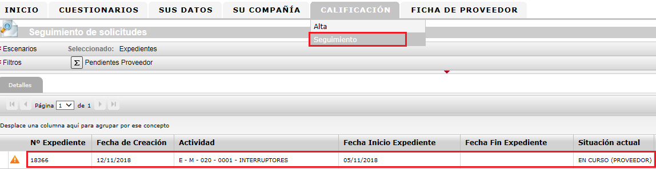The details of the file allow you to see the manager’s instructions in the Observations field.
Do the actions that have been indicated, in this case to update the annexed document in the questionnaire (option in the Questionnaire menu) and resubmit the file to the manager.
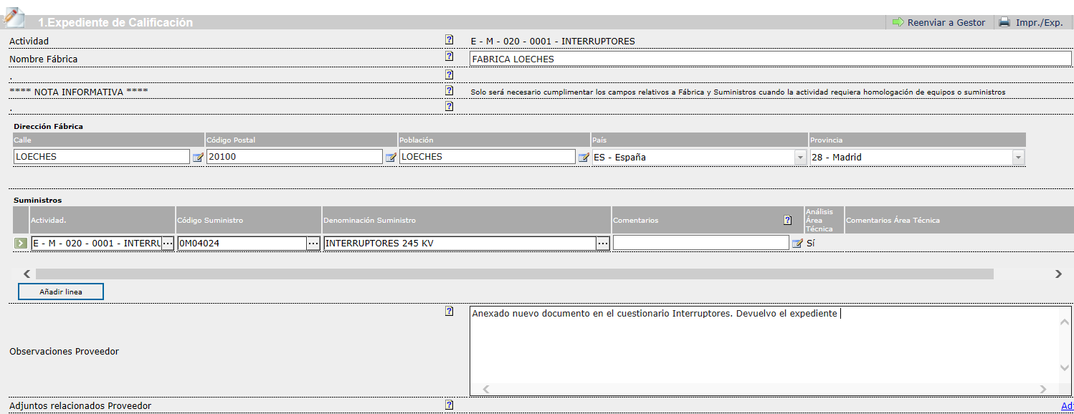We also have the option to add our own comments.

Click on the “Resend to Manager” button in the top right corner of the screen
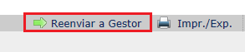

The system displays the following page where you have to click on the “Accept” button to proceed with the return of the qualification file to the manager.

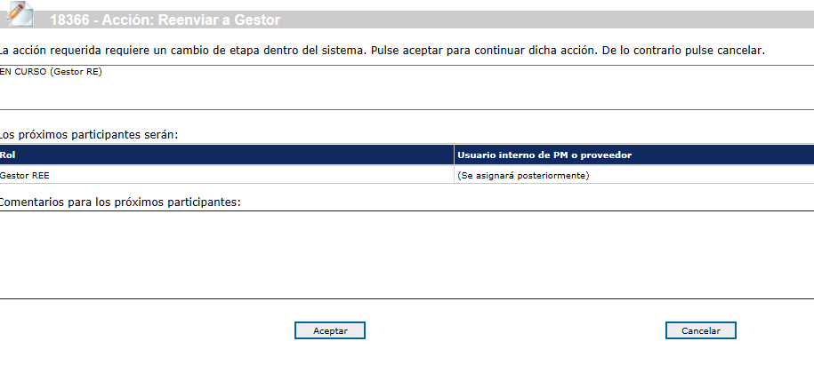

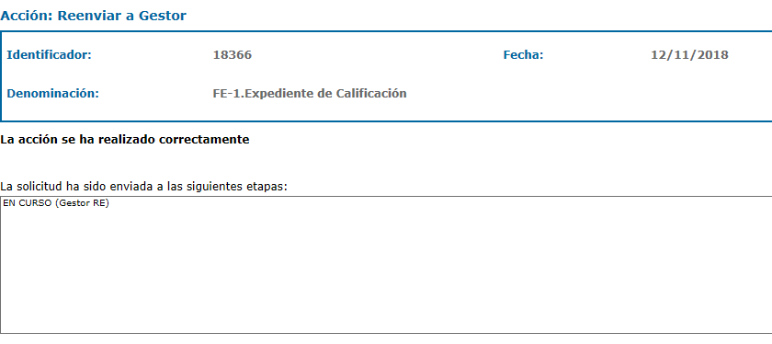To read the qualification file, return to the menu option
“Qualification – Monitoring”
The qualification file is no longer pending our action, so that the display does not contain any information.

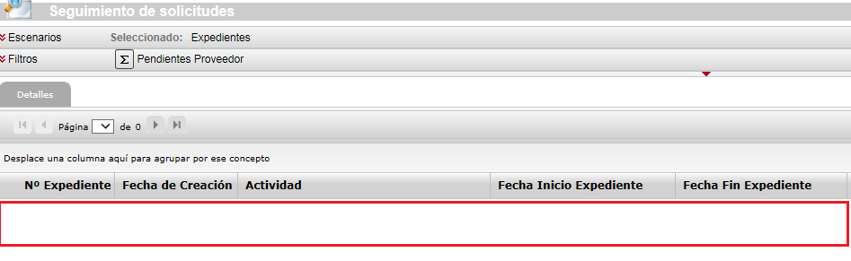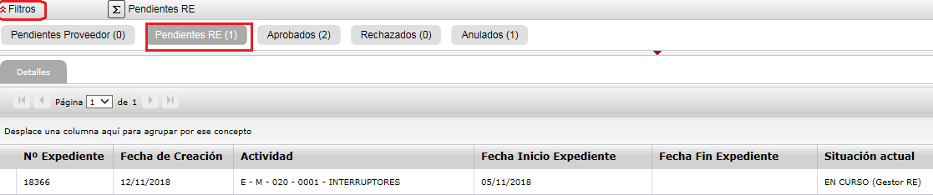If we click on “Filters”, we can find the file in the “Pending RE” section

As Supplier I do NOT return the File to the RE Manager within the set period (deadline for Return)

If the RE Manager returns a file for action and the deadline for returning it expires, it will automatically be cancelled.
You will receive an email message with the subject line:

Automatic file cancellation / RE Suppliers

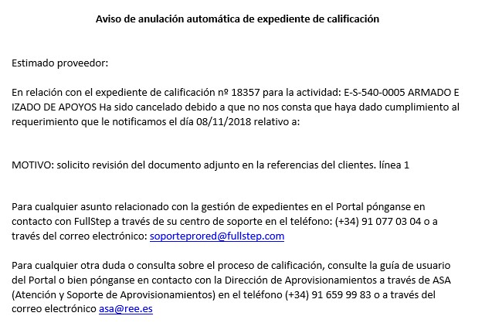The qualification process has been cancelled automatically by the system. We can
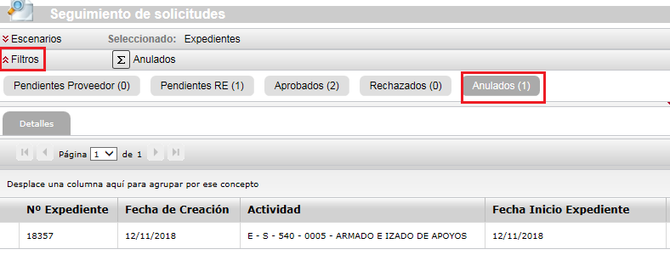consult the menu option “Qualification – Monitoring” using the Cancelled filter

We can request the registration of a new qualification file for the same activity. The process is the same as when requesting registration for the first time.
You will be asked to fill in the questionnaire associated with the business area. Its status will be Pending completion. When entering the details of the questionnaire, you will see that the data sent when processing the cancelled qualification file has been retained.
You can go over the information entered previously and submit the questionnaire again.

RE Manager > Approving the Qualification File

When the RE Manager has evaluated the information in the qualification file and has decided to approve it, the system will inform you automatically.
The body of the mail will show the number of the approved file and the business area.
The message itself with vary depending on the type of activity that qualification was requested for, with the status of the qualification or registration for the activity.

Type 1 Activity:
As regards the qualification file mentioned in this mail, we inform you that your company’s application to qualify as an RE supplier for the activity in question has concluded correctly. This means that your company now forms part of the supplier database of Red Eléctrica for this business area with the status of PENDING TEST ORDER. Your qualification for this activity will be consolidated, acquiring QUALIFIED status, when you successfully pass the test order which will be assigned to you in accordance with our financial technical criteria for assessing bids.

Type 2 Activity:
As regards the qualification file mentioned in this mail, we inform you that your company’s application to qualify as an RE supplier for the activity in question has concluded correctly. This means that as regards the materials / equipment requested in the relevant file for which you have been technically assessed, your company now forms part of the supplier database of Red Eléctrica for this business area with the status of PENDING TEST ORDER. Your qualification for these materials / equipment will be consolidated, acquiring QUALIFIED status, when you successfully pass the test order which will be assigned to you in accordance with our financial technical criteria for assessing bids.

Type 3 Activity:
As regards the qualification file mentioned in this mail, we inform you that your company’s application to qualify as an RE supplier for the activity in question has concluded correctly. This means that your company now forms part of the supplier database of Red Eléctrica for this business area with the status of PENDING TEST ORDER. We also remind you that, before you can be assigned part of this business area, you must have a minimum number of employees qualified to do the work. The Department responsible for this Activity in our company will inform you of the steps to take and any upcoming qualifying examinations. Once you have this skilled personnel, your qualification for this activity will be consolidated, acquiring QUALIFIED status, when you successfully pass the test order which will be assigned to you in accordance with our financial technical criteria for assessing bids.

Type 4 Activity:
As regards the file mentioned in this mail, we hereby inform you that your company has been registered in the supplier space for the activity that you have expressed an interest in.

Type 6 Activity:
As regards the qualification file mentioned in this mail, we inform you that your company’s application to qualify as an RE supplier for the activity in question has concluded correctly. This means that your company now forms part of the supplier database of Red Eléctrica for this Family with the status of QUALIFIED.

Unless the approved process is for a type 2 activity - Qualification with Approval, you cannot request registration for a new file for the same activity, because your company is already qualified.

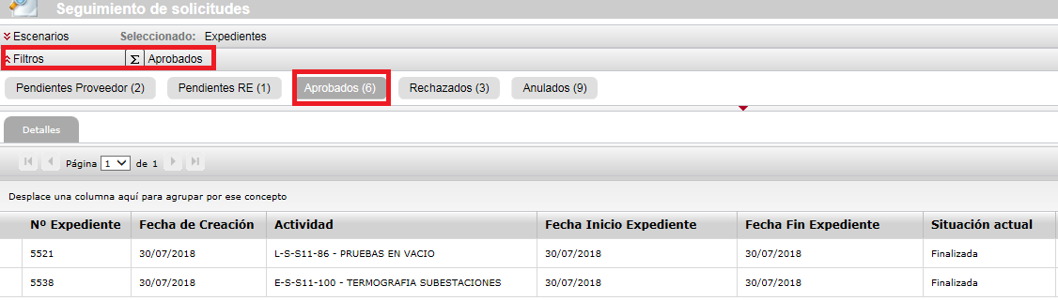You can consult the approved file by entering the menu option “Qualification – Monitoring”, using the “Approved” filter.

RE Manager rejects the Qualification file

When the RE Manager has assessed the information in the qualification file and decides to reject it, the system does not allow the registration of a new file for the same business area until the blockage time established by the supplier management has expired.

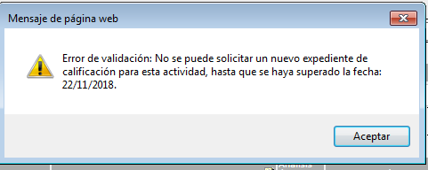

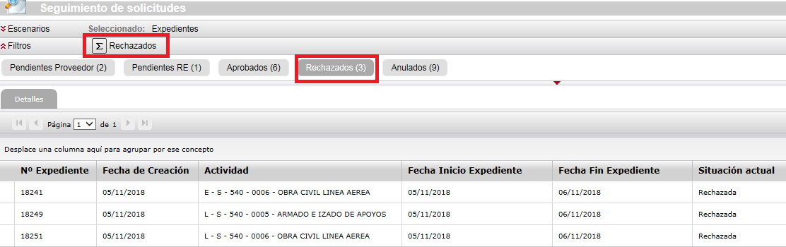You can consult the rejected file by entering the menu option “Qualification – Monitoring”, using the “Rejected” filter.

Click on any of the columns of the row corresponding to the rejected file number to see the details.
The “Qualification Details” tab allows you to check the expiry date for the block on
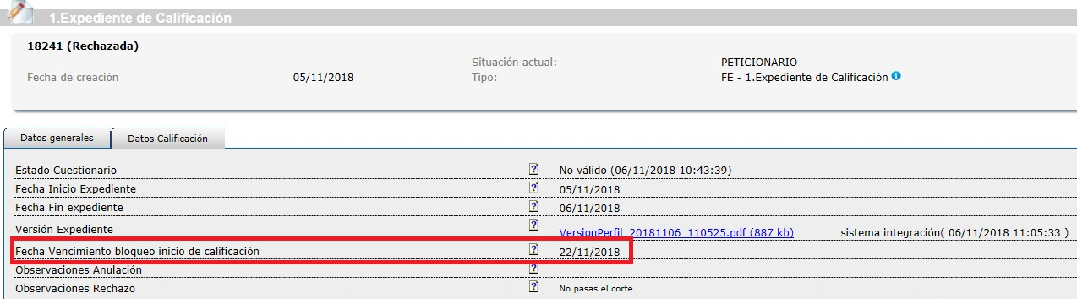Starting the qualification of a new file for the business area.

Other questionnaires: Repro and Axesor

RePro Questionnaire

If you want to qualify for type 1, 2, 3 and 6 Business areas, the supplier must be registered in RePro, a register managed by the Achilles company, before starting any qualification process.

You can check whether your details are available by looking at the “Questionnaires - Forms” menu option
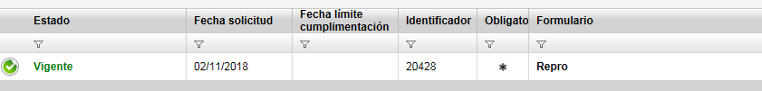in RePro in the supplier space.

You can see the Repro data by clicking on the name of the form.

This form is provided for information and is read only.
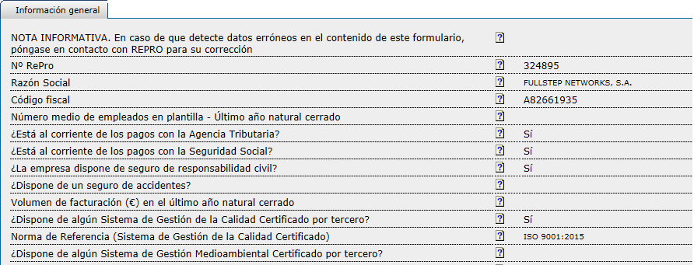If you see that any detail it contains is not correct, please contact Repro.

Axesor Questionnaire

You can check whether your details are in RePro supplier space by looking at the “Questionnaires - Forms” menu option

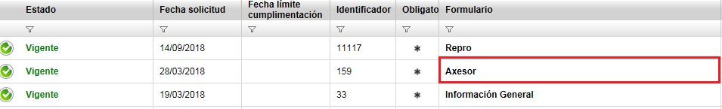You can see the Repro details by clicking on the name of the form.

This form is provided for information and is read only.
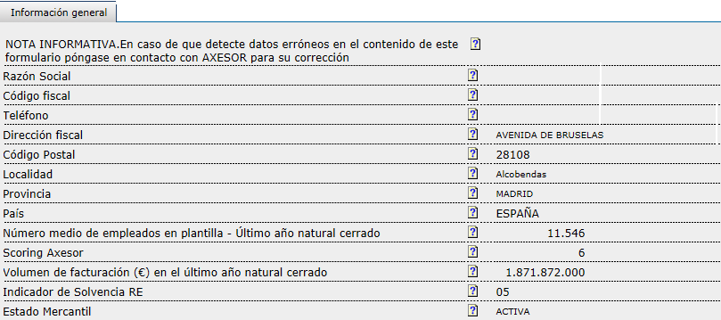If you see that any detail it contains is not correct, please contact Repro.

Supplier File

The Supplier File menu option lets you consult the basic data about your company that is available in the supplier space.

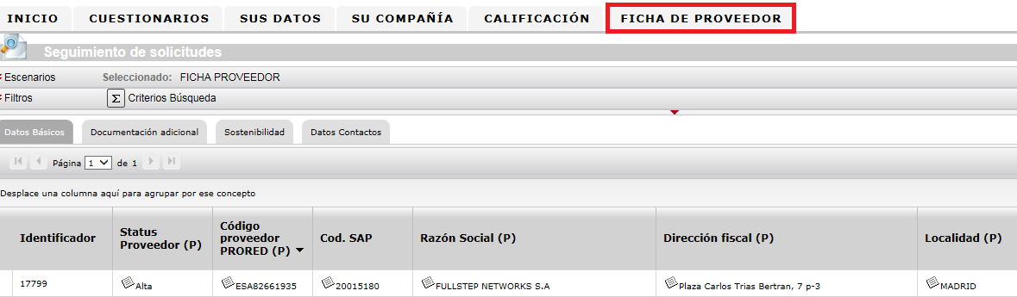Clicking on any of the visor columns will open the details of the file in consultation mode. You cannot update any details from this section.

The supplier file contains the details of your company and structures the information in 4 blocks:
- General Information
- Additional Documents
- Sustainability Information
- Qualification Statuses

The data contained in the supplier file can be sourced from:
- REPRO. Name of Field with (R)
- AXESOR > Name of Field with (A)
- Information filled in in the Supplier space > Name of Field with (P)

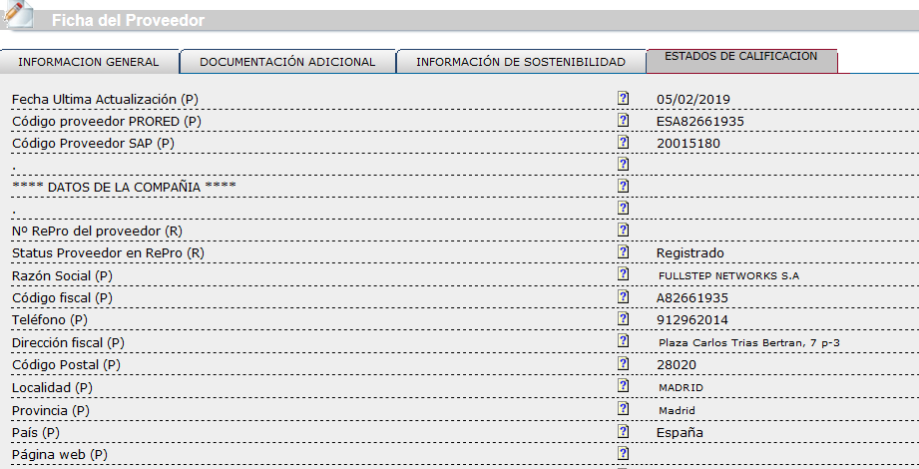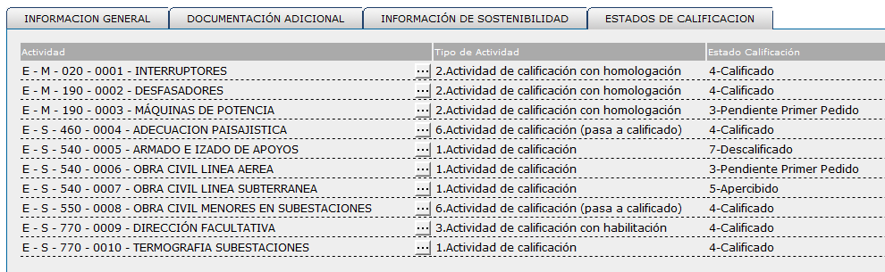The “Qualification statuses” tab shows the business areas that the company is qualified for, the type of activity and qualification status.

Qualification Report

In this menu option you can download the report on qualification statuses of your company at the time of compiling the report.
If your company does not have a qualification status, the system will show the following message when entering the menu option "Qualification Report”:
“There are currently no qualification statuses for any activity”

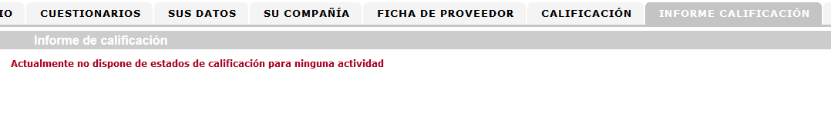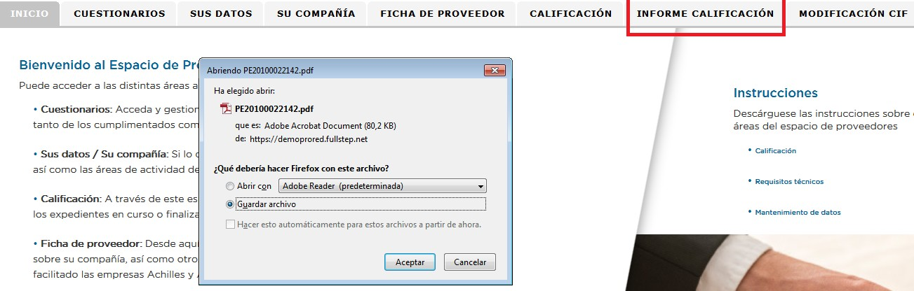If there is a qualification status, the system will create a report (“.pdf” file) and the browser will ask whether you want to open or download it.

Firefox Browser. Generation of a qualification report. Download or Open report in “pdf” format

Internet Explorer Browser. Generation of a qualification report. Download or Open report in
“pdf” format. Footnote.

An example of printing the qualification status report is shown below:

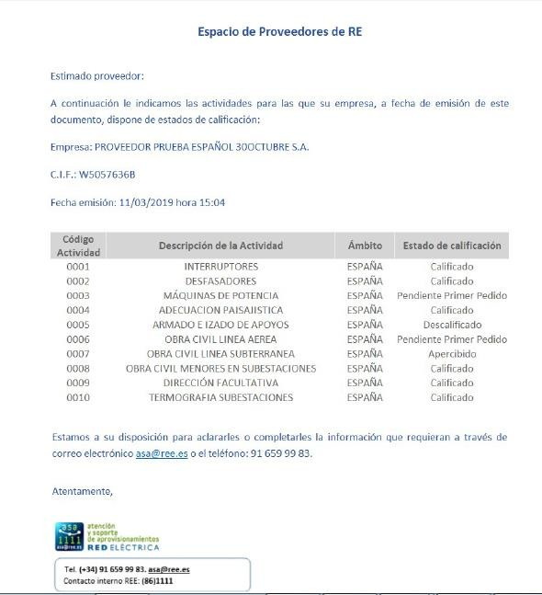Tax ID No. (CIF) Modification Report

Introduction

You can use this type of request, as an RE supplier, to ask for a change of your CIF through the RE Suppliers Space.

This guide will guide you through the steps to follow when you want to request a change of CIF for: merger, absorption, demerger, changes of CIF for the same company and others.
There are several pre-requisites that must be complied with before requesting a change of CIF:
- The request for a change of CIF must be submitted by the new company.

- This new company must be registered on ProRed, with the new CIF and later completed the General Information questionnaire.

- Once the process of changing the CIF is complete, you can access the information related with this change by opening the details of the request. The CIF of the former company will be deleted from the Prored supplier space.

CIF Modification Request Registration

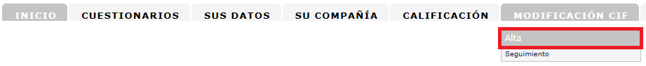As an authorized supplier you can issue a CIF modification request by entering the menu option “CIF Modification > Registration”

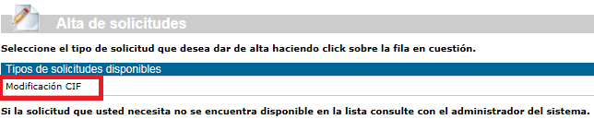The system will then display the “CIF Modification” request type

Click on the title and the system will display the form with the data to be completed by the supplier.

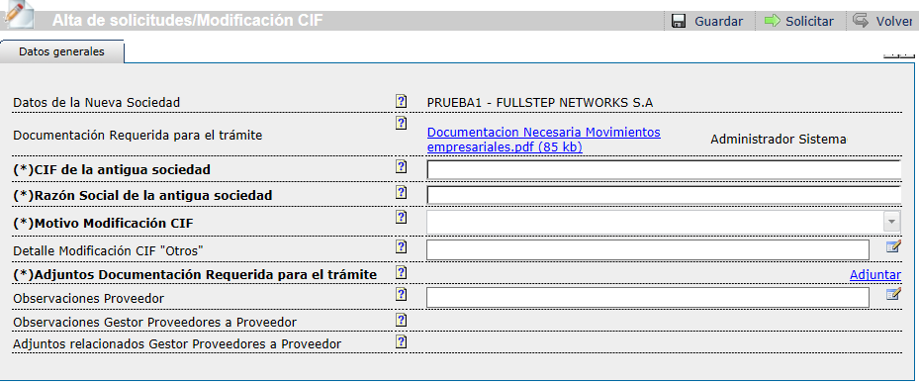

CIF Modification Form

Documents required for the process

The fields preceded by (*) in bold format are mandatory for the request to proceed. They must indicate the CIF and name of the former company and the reason for modifying the CIF.
Some documents are also required for the process to continue. The documents in question can be seen in the file “Documents Necessary for Business Movements.pdf”.
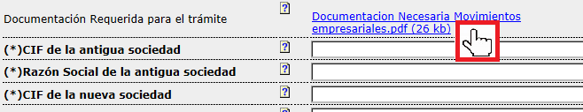Click on the link of the “Documents Required for the process” field

Your browser will now either open or download the document:

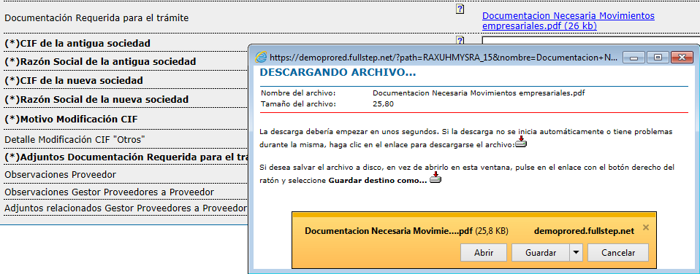Example of the message to download/open the document with INTERNET EXPLORER BROWSER

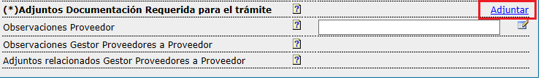Once you have the relevant documents, attach them to the field Attached Documents Required for the process.

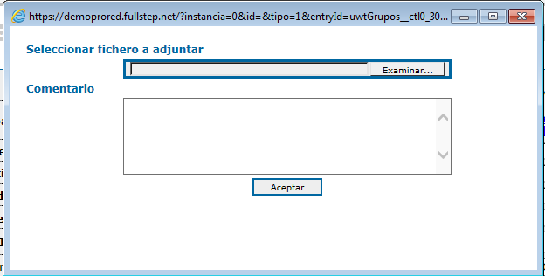Clicking on the “Attach” link will open a window like the one shown in the image. Choose the file to attach using the Examine button. You can also add write comments on the file, for example a title for the file you are attaching. You can then click on the Accept button. The file will be added to the request.

You have the option to include comments in the “Supplier Comments” field

The fields Manager Comments Suppliers to Supplier and related attachments are not editable. They are intended for the RE supplier manager who is processing the request.

Reason for Modifying CIF

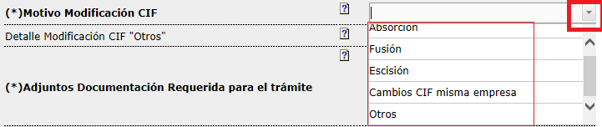You have to choose one of the values in the list suggested by the “CIF Modification” field.

If the reason is not included among these values: Absorption, Merger, Demerger, CIF change for the same company, select the “Others” option and write the relevant comments in the field.

If the CIF Modification Details “others” field is empty when clicking the “Request” button, the system not send the request and will show the following message.
You can use the horizontal scroll bar to read the text of the block message.

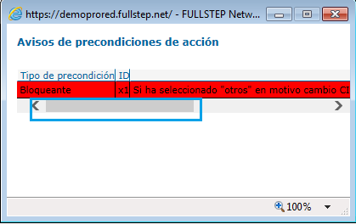

Request CIF Modification Registration

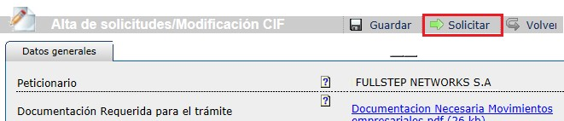Click on the “Request” button to issue the request

The system will ensure that all the mandatory fields are filled in.
If not, the system will show a message to indicate which field is still pending:

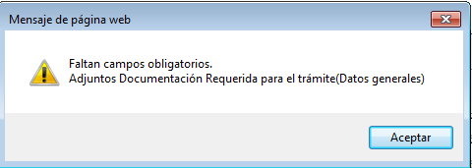

If all the mandatory fields are filled in, the system will show the next page, where you do not have to add any comment for the next participants.

You have to click on the “Accept” button again to confirm the registration of the request.

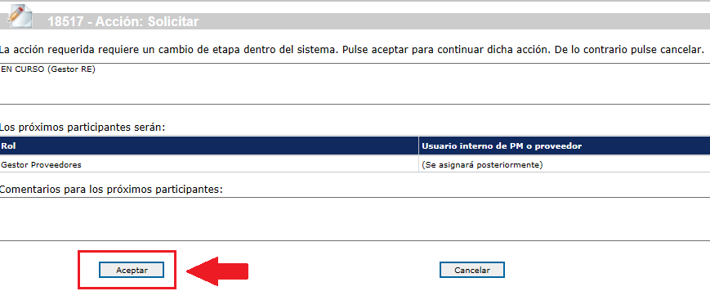Issue request Click on ACCEPT to Continue

The request number is indicated at the top of the page.
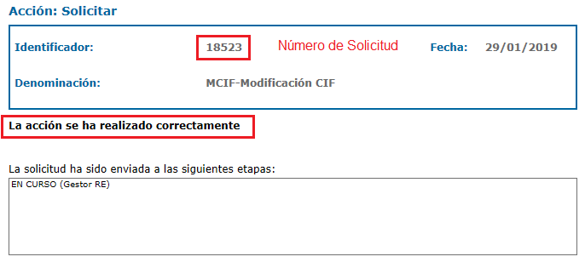The system will then show a page to confirm that the action has been performed correctly.

Confirmation page. Request sent correctly

Other action buttons: “Save” ->
The system will generate a unique numerical identifier for the request. The request has NOT been sent.

We can access the saved request from the menu option “monitoring -> “Pending Supplier”. The changes to the form can be applied before finally clicking on the Request button to make the registration effective.

CIF Modification Request Monitoring

To see the status of the CIF modification request, open the menu option:
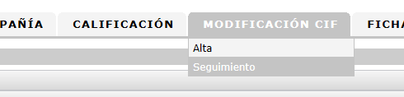“CIF Modification – Monitoring”

In this option, we can see different filters to consult the requests according to their processing status.
Filters:
Pending: Requests pending processing by the supplier. Either because the supplier manager has returned it or because they have been saved but not issued.
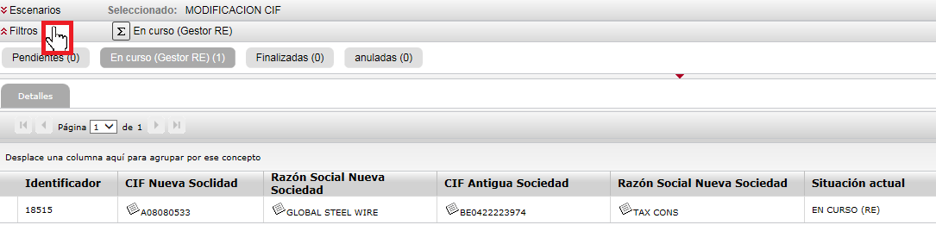In Progress (RE Manager): Requests being processed by RE. Ended: Requests already processed and which are finished. Cancelled: Requests cancelled by the supplier manager.

Click on any of the columns to access the details of the request.

RE Manager returns the request

Once the CIF modification request has been issued, the RE supplier department will begin to review it.
The RE Manager may return the request to the supplier because more documents are required or to clarify some of the information that it contains.
if this happens, the user who submitted the request will receive an email message with the subject line:

CIF Modification Request Return
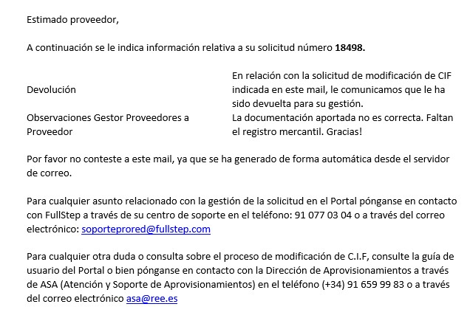The body of the mail will contain the comments of the supplier manager explaining the reason why it has been returned.

Entering the Supplier Space, using the menu option “CIF Modification – Monitoring” and the “Pending” filter, you will find the request pending your action.
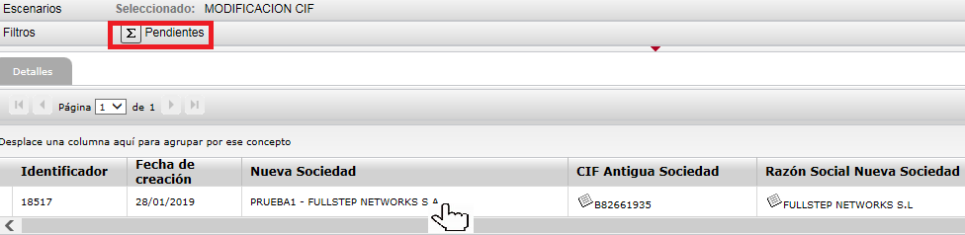Click on any of the columns shown to access the details of the request

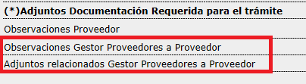The fields highlighted below in red will contain the reason for the return.

As Supplier I return the request to the RE Manager

The details of the request allow you to see the instructions under “Manager’s comments”.
Make any relevant changes, which in this example means updating the documents required for the process and resubmitting the request to the manager, clicking on the “Request” button again.
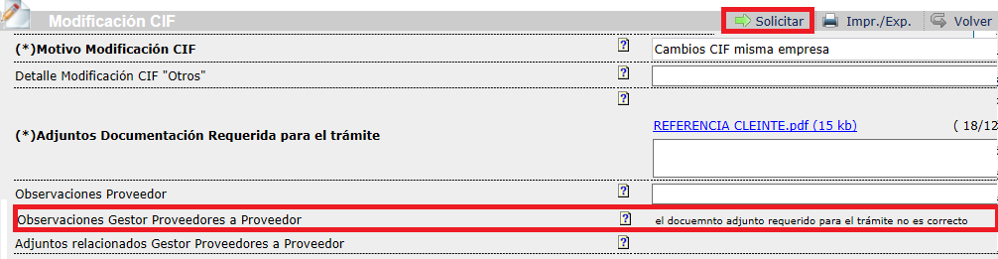We also have the option to add our own comments.

The system displays the following page where you have to click on the “Accept” button to
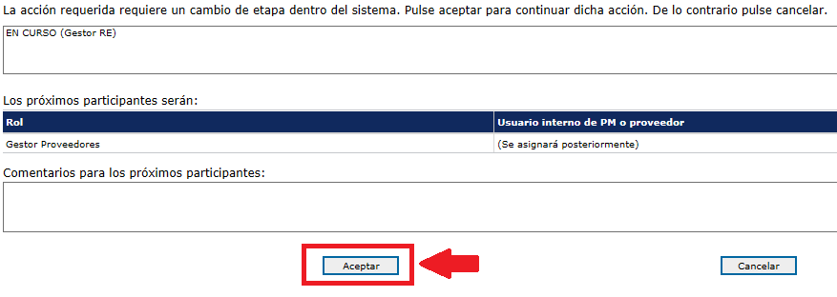resubmit the request to the supplier manager.

The request is no longer pending our action, therefore, the “Pending” display
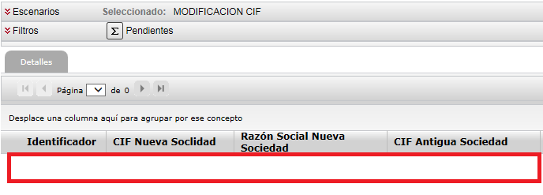does not contain any information.

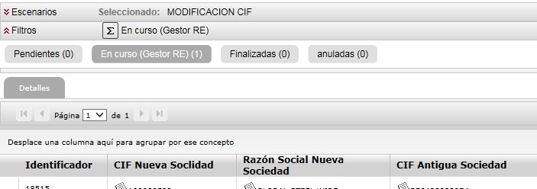If we click on “Filters”, we can find the file in the “In Progress (RE Manager)” section

RE Manager approves the request

When the request has been processed in the REE systems, you will receive an e-mail like the one shown below:

Subject: CIF Modification Request Approved

The body of the mail will contain the number of the finished request.

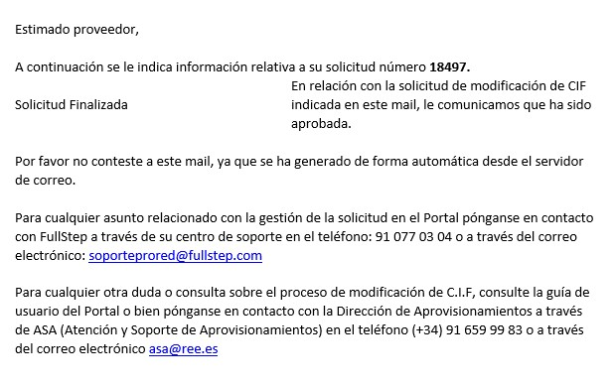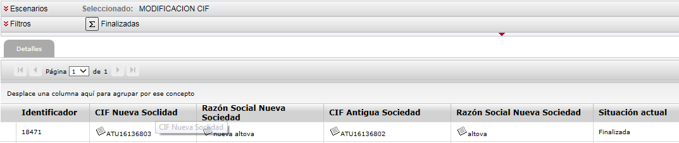Entering the Supplier Space, using the menu option “CIF Modification – Monitoring” and the “Ended” filter, you will find the processed request.

RE Manager cancels the request

The supplier manager can cancel a CIF Modification request when this is not required or cannot be processed. For example, if the CIF request has been issued in duplicate.
If the CIF modification request is cancelled, the system will notify the submitting user automatically
The subject line of the mail notification is:

CIF Modification Request Cancellation

The body of the mail will contain the number of the cancelled request.

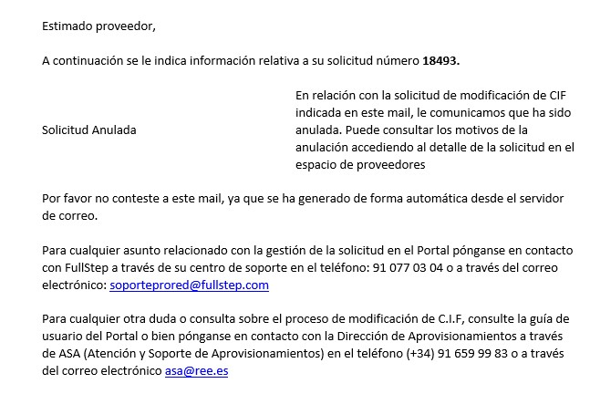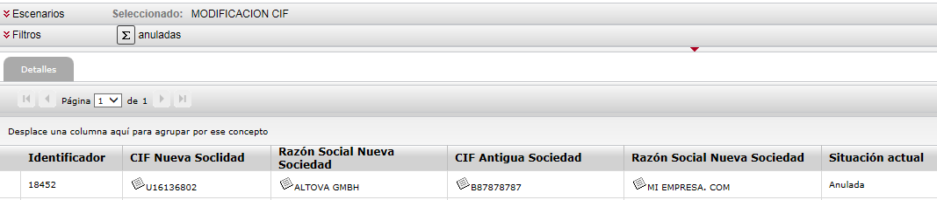To see the reason for the cancellation, enter the Supplier Space, using the menu option “CIF Modification – Monitoring” and the “Cancelled” filter to find the request which has been cancelled.

Clicking on any of the first columns will show the details of the request and the “Supplier Manager to Supplier Comments” field will contain the comments related with the cancellation.

